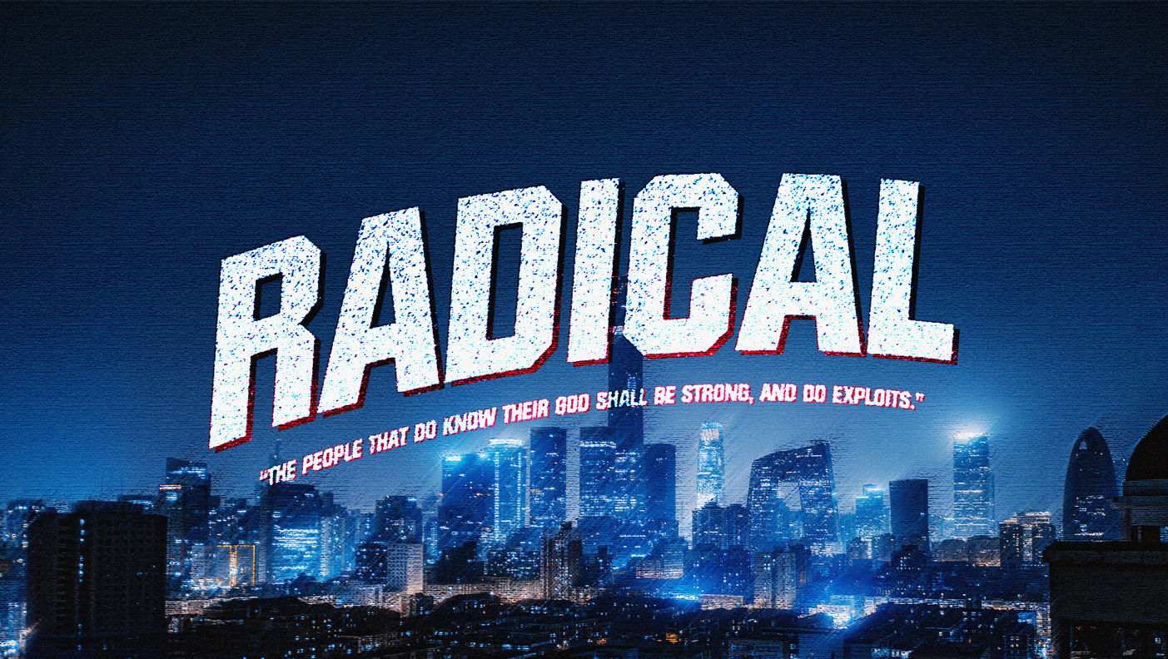
WEEK 4 - RADICAL BOLDNESS

SERIES BIG IDEA
When we choose to live radically for God, He will do radical exploits through us. This series will explore the role of young people in the end-time harvest through radical devotion, faith, conviction, and boldness.

BIBLICAL PASSAGE
Daniel 3:16–18; 11:32; Acts 4:23–31

BOTTOM LINE
Fear and worry does not have to stop us; today through the power of the Holy Ghost, we can walk boldly through our situations to fulfill end-time revival.

LAUNCH
Option 1 - Fear Factor
- Host a scaled-back version of Fear Factor. Use the game as a teaching moment for students to be brave and overcome fears.
- Example: Fill a shoebox with dirt, worms, and other gross sensory objects. Hide five pennies in the dirt. Without giving too much information away, tell students that live creatures are in the box with the pennies. Time each student to see who can find the pennies the fastest. Offer a reward to the bravest and fastest student.

Option 2 - Identify Your Fears
- Hand each student paper and a pen.
  - Ask students to write down their five greatest fears.
  - Ask for volunteers to share their fears and briefly describe why they have these fears.
- By writing down your fears, you can identify which are healthy and which are holding you back.
  - You can reveal opportunities for growth and healing.
  - You can set some goals that are important, even though they scare you.

Option 3 - Personal Testimony
- Ask for volunteers to share their personal testimony of a place and time when God gave them boldness to do something. It could have been at a camp, during a local church service, at their home, or in another place where God moved upon them.
- Ask them to share where it was, who they were with, and what happened during that moment.

UNLOCK
- Living in the Last Days
  - Read II Peter 3:1–4.
  - Peter finished his second book by giving a clear reminder about the way people will act in the last days. He stated there will be “scoffers.” The word scoff means to mock. People will ridicule those who believe in the return of Jesus Christ.
  - A telephone survey of one thousand pastors, facilitated by Lifeway Research in 2016, concluded that only one-third of Protestant pastors believe in the rapture of the church. Many believe that number continues to decline as time marches forward. It is only logical to conclude that since people of faith believe in the rapture less and less, the world will believe much less.
  - Peter’s reminder in this passage is to be mindful of the words spoken by the holy prophets and the commandments of the apostles. As we see the day of Jesus’ return approaching, we have a place to set our minds: the Word of God.
  - We must not believe the cynical mockers. We must not fear the audacious headlines. We must not be swayed by popular influencers of culture. Our road map to eternity has been given to us through the doctrine of Scripture.
  - The people of God must display boldness in these last days. The boldness of truth will endure the cynicism of the scoffer. God’s truth endures to all generations, even the last one.
- Week 3 Recap
  - Conviction is being convinced and confident that something is true. Having conviction means being strong persuaded of and loyal to truth and what is right.
  - When we pursue God and let Him shape our character, we are laying the groundwork for strong convictions.
  - Standing out may be uncomfortable and difficult, but we were made to stand out to this world.
  - Radical conviction is a commitment to truth no matter the threat or outcome.
- Boldness in Daniel
  - The Book of Daniel contains many examples of boldness. In the midst of dangerous times, the people of God boldly withstood the pressures of their times.
  - Read Daniel 3:16–18.
  - King Nebuchadnezzar had a ninety-foot-tall statue built for everyone in Babylon to worship. He sent invitations across the kingdom to all levels of society to attend the dedication of his image.
  - The people had strict orders that when they heard the music play, they were to immediately fall down and worship the image. Anyone who defied the king would be cast into the midst of a furnace of fire.
  - Shadrach, Meshach, and Abednego were Jews exiled to Babylon but who had found favor from God with the king. These three men refused to bow down and worship an idol. The fact that only three young men among all the exiles refused to bow is a testament to their radical devotion, faith, and conviction.
  - When offered a second chance to bow and a challenge to the God of the Jews, the young men quickly and concisely told the king that their God was able to deliver them. But even if He didn’t, they refused to worship any other god.
  - Facing death by a fiery furnace, Shadrach, Meshach, and Abednego boldly declared their faith in their God.
- Boldness in Acts
  - The disciples in the early church walked in boldness. Many times, their actions and responses were empowered by a supernatural boldness given by God for their environment.
  - Read Acts 4:23–31.
  - In Acts 3, Peter and John were part of a miracle. A man who had been unable to walk from birth was healed and gave God the praise. This supernatural healing opened the door for Peter to declare the gospel of Jesus Christ to the crowd (Acts 3:19-20).
  - As Peter and John declared truth to the people, certain religious leaders arrived and became upset that they were preaching about Jesus Christ. After arresting and imprisoning the disciples overnight, the religious leaders tried to discourage their preaching and their mission. However, the most glaring attribute about the disciples was their boldness.
  - Since the religious leaders could do nothing else, they threatened the disciples to discontinue teaching and speaking the name of Jesus.
  - Upon the disciples’ return to the company of believers, the church lifted their voice in prayer. With passion and purpose, the church asked to be given supernatural boldness to speak the Word and be a part of signs and wonders.
  - The result of this prayer meeting was a great shaking and infilling of the Holy Ghost, and they spoke God’s Word with boldness.
  - Facing great threats, the people of God didn’t ask for their trials to be removed. They petitioned God for supernatural boldness to overcome.

INTERSECT
- What Is Boldness?
  - Read II Timothy 1:7–10.
  - Many of us fight against fear, doubt, and shame. These oppositions to our faith have never been more prevalent. However, we have a promised attribute that comes from God: boldness. When He fills us with His Spirit, He gives us the power to overcome.
  - Boldness is courage to execute the will of God.
  - Boldness is freedom. It is freedom to talk and walk in the confidence that comes from God and His Word. When Christians have boldness, they will reject the fear and lies of the enemy and view the world through the lens of faith, hope, and love.
  - Shame and fear are opposites to boldness. These two feelings—shame for what we’ve done and fear for what we cannot do—will always try to combat the Spirit of God living inside us.
  - Read Ephesians 3:10–12.
  - Boldness is rooted in the perspective of God’s power and our placement in His kingdom. When these two things meet, boldness will be present. We must believe that God is able to do great things throughout our lives.
  - Boldness is a key that unlocks faith to do great exploits.
- Boldness Is Expressed through Speech
  - Shadrach, Meshach, and Abednego declared their boldness through their verbal response to the king. They boldly declared that God was able to deliver them from the pagan king’s fiery furnace.
  - The first church prayed for God to give them boldness to speak His Word. Their request went beyond an inward courage to an outward expression.
  - Read Psalm 71:8.
  - In the Greco-Roman world, a full-fledged citizen was encouraged to speak freely and candidly. As a full-fledged citizen of God’s kingdom, we are encouraged to open our mouths and declare the Word of God in faith.
  - Repeatedly in the Book of Acts, boldness is tied to speech.
    - Acts 9:27—“preached boldly”
    - Acts 13:46—“waxed bold, and said”
    - Acts 14:3—“speaking boldly in the Lord”
    - Acts 19:8—“spake boldly for the space of three months”
  - As the people of God living in the last days, we must boldly speak the Word of God. Our faith in God’s power must be boldly expressed through our speech.
- Boldness Will Replace Fear
  - The Hebrew young men were in the middle of a fearful and compromising environment. Living in a foreign land with little spiritual support, they could have easily bowed to fear by bowing to the image.
  - The early church could have easily believed the threats and surrendered to fear. All spiritual momentum could have been lost if they let worry and caution overtake passion and faith.
  - Instead of fear, God gave us power, love, and a sound mind. Boldness is a key that unlocks faith.
  - If the kingdom of darkness uses fear, then the kingdom of Heaven uses boldness. As a youth or young adult serving God, you have access to a powerful weapon. As boldness increases in your life, fear will decrease.
  - Read Proverbs 28:1.
- Radical Boldness
  - When Nebuchadnezzar threw the three Hebrew men into the fire, he couldn’t believe the result. Not only were the young men not harmed, but he saw a fourth in the form of the Son of God. Something supernatural took place.
  - When the church finished praying for boldness in Acts 4, they witnessed a supernatural activity. The place began to shake under the power of God.
  - God wants to do great exploits through your life. As you declare and act in boldness, the doors to the supernatural will open.
  - Radical boldness produces a radical demonstration by God.

ARRIVE
Option 1 - Postscript
- Boldness is a key to faith.
  - Shadrach, Meshach, and Abednego radically defied the threat of the king by boldly declaring their worship.
  - The early church radically defied the threat from the religious authority by seeking boldness to overcome.
- Lead a group discussion with these questions:
  - Why do you think the enemy uses fear as a major weapon against God’s people?
  - Why do you think it’s difficult to be bold?
  - What is one act of boldness for God you can do this week?
  - What is one bold declaration you would make over your youth group?

Option 2 - Prayer
- Choose a song to play and give students an opportunity to respond in prayer.
- Seek for an Acts 4 demonstration where the place shakes and students are emboldened to perform God’s will.

Option 3 - Take Home
- Create or purchase an item each student can take home as a reminder of this series. (Examples include keychains, bookmarks, bag tags, stickers, or decals.) The item should be quality enough to last after being place in their car, on their bathroom mirror, beside their bed, and so on.
- Provide each student with the item or materials to make it. Have students write or create the phrase “Be Bold” or “Be Radical” on it. Encourage them to take it with them for display.

